

Network Security and Forensics

Lab Session 2

Submitted To:- Submitted By:-

Dr. Lokesh Chauhan Sir Saloni Rangari

M.Tech. AIDS

# Study and demonstration of network Cable.

* + Forming of network cable CAT-6 cables

Category 6 (CAT-6) cables are a type of twisted pair cable standard used for Ethernet and other network physical layers. CAT-6 cables are backward compatible with the Category 5/5e and Category 3 cable standards. They support Gigabit Ethernet and are capable of transmitting data at a rate of up to 10 Gbps, with a maximum frequency of 250 MHz.

## Key Features:

* Twisted Pair: Each cable contains four pairs of copper wires, each twisted together to reduce interference from external sources.
* Bandwidth: Up to 250 MHz.
* Speed: Supports up to 10 Gbps Ethernet (10GBASE-T).
* Distance: Maximum length of 55 meters for 10 Gbps, up to 100 meters for lower speeds (1 Gbps or 100 Mbps).

## Materials Needed for Forming CAT-6 Cables:

1. CAT-6 Cable: Unshielded Twisted Pair (UTP) cable.
2. RJ-45 Connectors: For terminating the cable.
3. Crimping Tool: For attaching the RJ-45 connectors to the cable.
4. Cable Stripper/Cutter: For stripping the outer sheath of the cable and cutting it to length.
5. Cable Tester: To test the continuity and proper wiring of the cable.

## 3.Steps to Form a CAT-6 Network Cable:

1. Cut the Cable to the Desired Length:
   * Use the cable cutter to cut the CAT-6 cable to the length required for your network setup.

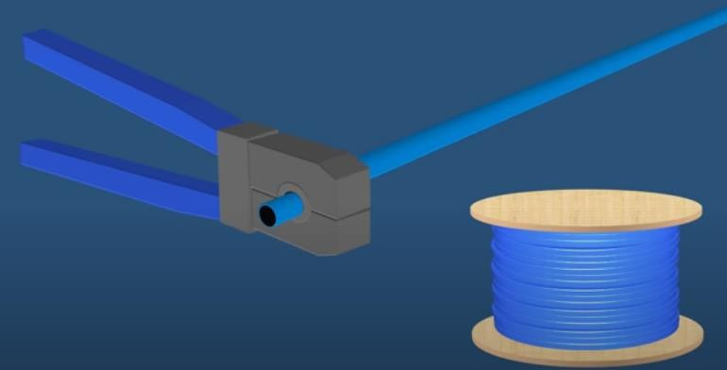

1. Strip the Cable Jacket:
   * Using the cable stripper, remove about 2-3 cm of the outer jacket from both ends of the cable. Be careful not to nick the wires inside.
2. Untwist the Pairs:
   * Untwist the pairs of wires inside the cable jacket. There are four pairs (eight wires in total), each pair twisted together.

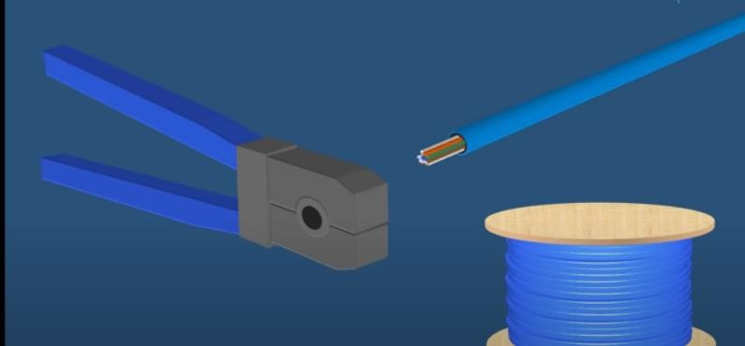

## Arrange the Wires:

* + Align the wires according to the wiring standard you are using. The two common wiring standards are T568A and T568B.
  + T568A Wiring Order:

1. White/Green
2. Green
3. White/Orange
4. Blue
5. White/Blue
6. Orange
7. White/Brown
8. Brown
   * T568B Wiring Order:
9. White/Orange
10. Orange
11. White/Green
12. Blue
13. White/Blue
14. Green
15. White/Brown
16. Brown
    * Ensure all wires are straightened and aligned before proceeding.

## Trim the Wires:

* + Trim the wires evenly so that they are about 1.5 cm long from the cable jacket.

## Insert the Wires into the RJ-45 Connector:

* + Carefully insert the wires into the RJ-45 connector, making sure each wire is fully seated in the connector and in the correct order. The flat side of the RJ-45 connector should be facing you.

## Crimp the Connector:

* + Place the RJ-45 connector with the inserted wires into the crimping tool.

Squeeze the crimping tool firmly to secure the connector to the cable.



## Repeat on the Other End:

* + Repeat steps 2-7 for the other end of the cable, ensuring that both ends follow the same wiring standard (either T568A or T568B).

## Test the Cable:

* + Use a cable tester to check for proper continuity and correct wiring. The tester will indicate if all the connections are correct and if there are any faults.

# 2. Study of various internetworking devices

-Hub

-Switches

-Routers

## Hub

* A hub is a basic networking device that connects multiple devices in a network.
* It operates at the Physical Layer (Layer 1) of the OSI model.

## Function

* Broadcasting Data: When a hub receives a data packet from one of its ports, it broadcasts the data to all other ports, regardless of the intended recipient.

This can lead to data collisions and inefficiencies.

* Half-Duplex Communication: Hubs support half-duplex communication, meaning data can be transmitted or received, but not simultaneously.

## Advantages

* Simple and Cheap: Hubs are inexpensive and easy to install.
* Basic Connectivity: Suitable for small, simple networks where traffic is minimal.

## Disadvantages

* Inefficient: Broadcasting data to all devices leads to unnecessary network traffic and potential collisions.
* No Filtering: Hubs cannot filter or manage traffic, leading to security vulnerabilities.

## Use Case

* Hubs are largely obsolete and have been replaced by more advanced devices like switches. They were once used in small, low-traffic networks.

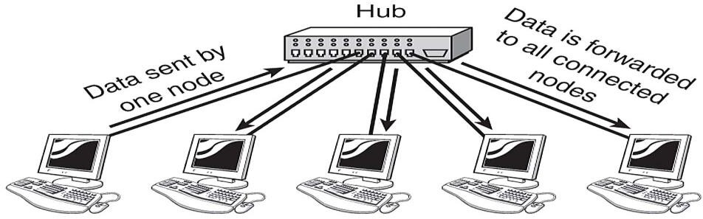

## Switch

* A switch is a more advanced networking device that connects multiple devices and manages data flow between them.
* It operates at the Data Link Layer (Layer 2), and some switches can operate at the Network Layer (Layer 3).

## Function

* Data Filtering and Forwarding: Switches use MAC addresses to intelligently forward data to the correct device, rather than broadcasting to all devices like a hub.
* Full-Duplex Communication: Switches support full-duplex communication, allowing simultaneous transmission and reception of data.
* VLAN Support: Some switches support Virtual LANs (VLANs), allowing the segmentation of networks into different logical groups.

## Advantages

* Efficient Data Handling: Reduces unnecessary traffic by only sending data to the intended recipient.
* Improved Network Performance: Minimizes data collisions and supports higher bandwidth.
* Scalability: Suitable for larger networks with many devices.

## Disadvantages

* Cost: More expensive than hubs.
* Complexity: Requires more configuration and understanding of network design.

## Use Case

* Switches are commonly used in small to large networks, including home, office, and enterprise environments, to connect computers, printers, and other devices.

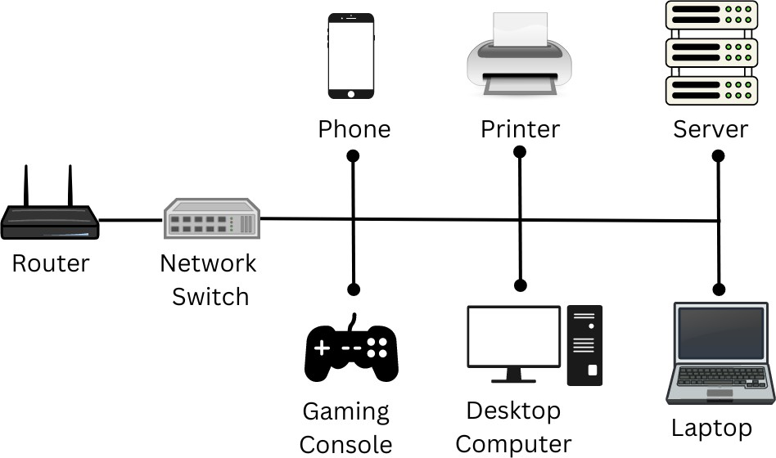

## Router

* A router is a networking device that connects multiple networks together, typically connecting a local network to the internet.
* It operates at the Network Layer (Layer 3) of the OSI model.

## Function

* Routing Data Packets: Routers use IP addresses to determine the best path for data to travel from one network to another.
* Network Address Translation (NAT): Routers can translate private IP addresses to a public IP address for internet access.
* Firewall and Security: Many routers have built-in firewalls and security features to protect networks from unauthorized access.
* Dynamic Routing Protocols: Routers can use protocols like OSPF, BGP, or RIP to dynamically adjust routes based on current network conditions.

## Advantages

* Interconnectivity: Allows different networks to communicate with each other.
* Traffic Management: Routers can prioritize and manage traffic, improving network performance.
* Security: Provides a layer of security between networks, especially between a local network and the internet.

## Disadvantages

* Complex Configuration: Routers can be complex to configure, especially in larger networks.
* Cost: More expensive than hubs and switches.

## Use Case

* Routers are essential in any network that connects to other networks, such as home networks connecting to the internet, or in enterprise networks connecting multiple branches.

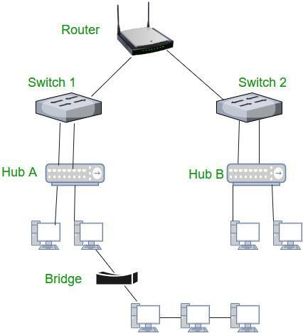

## Comparison

* Hubs are simple and cheap but inefficient, largely replaced by switches.
* Switches offer intelligent data handling, improving network efficiency and performance, making them suitable for most network environments.
* Routers connect different networks, providing interconnectivity, traffic management, and security, crucial for any network requiring internet access or communication between multiple networks.

# 3. Demonstration of IP change and scanner.

## IP Change Demonstration

* + VPN (Virtual Private Network): The easiest way to change your IP address is by using a VPN service. A VPN masks your real IP address and assigns you a new one from the server you're connected to.
  + Proxy Server: A proxy server also allows you to change your IP address.

When you connect to a proxy, your internet traffic is routed through the proxy server, making it appear as though the traffic is originating from the proxy's IP address.

* + Manually Change IP (Windows):
    - Open Command Prompt.
    - Type `ipconfig /release` and hit Enter.
    - Then type `ipconfig /renew` to request a new IP address from the DHCP server.

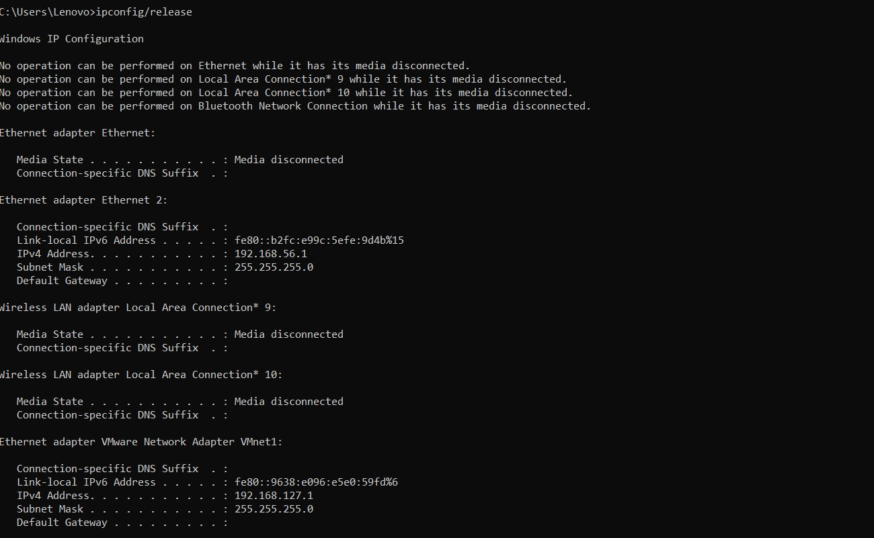

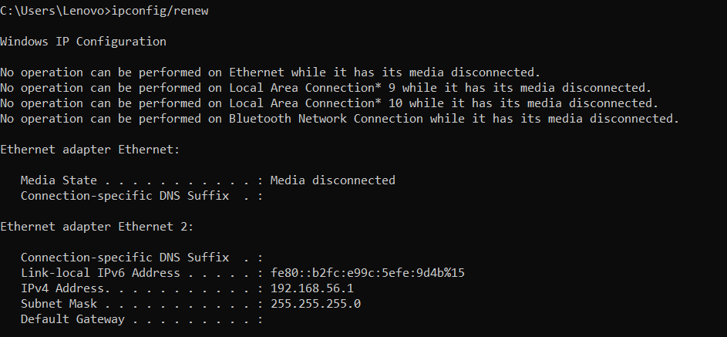

## Network Scanning Demonstration

* + Using Nmap:
    - Nmap (Network Mapper) is a free and open-source tool used for network discovery and security auditing.
    - To scan a network, open a terminal and type `nmap -sn 192.168.1.0/24` to perform a ping scan on the network range.
    - To scan for open ports on a specific IP, use `nmap -p 1-65535

<target_ip>`.

## Network Scanning using Nmap:

* + Install Nmap on your system (`sudo apt-get install nmap` for Linux).
  + Run a scan on your local network: `nmap -sn 192.168.1.0/24`.
  + Review the results to see the active devices on the network.
  + Run a port scan: `nmap -p 22 192.168.1.1` to check if SSH port 22 is open on a specific device.

